WorkHorse3D Printer - Wiring
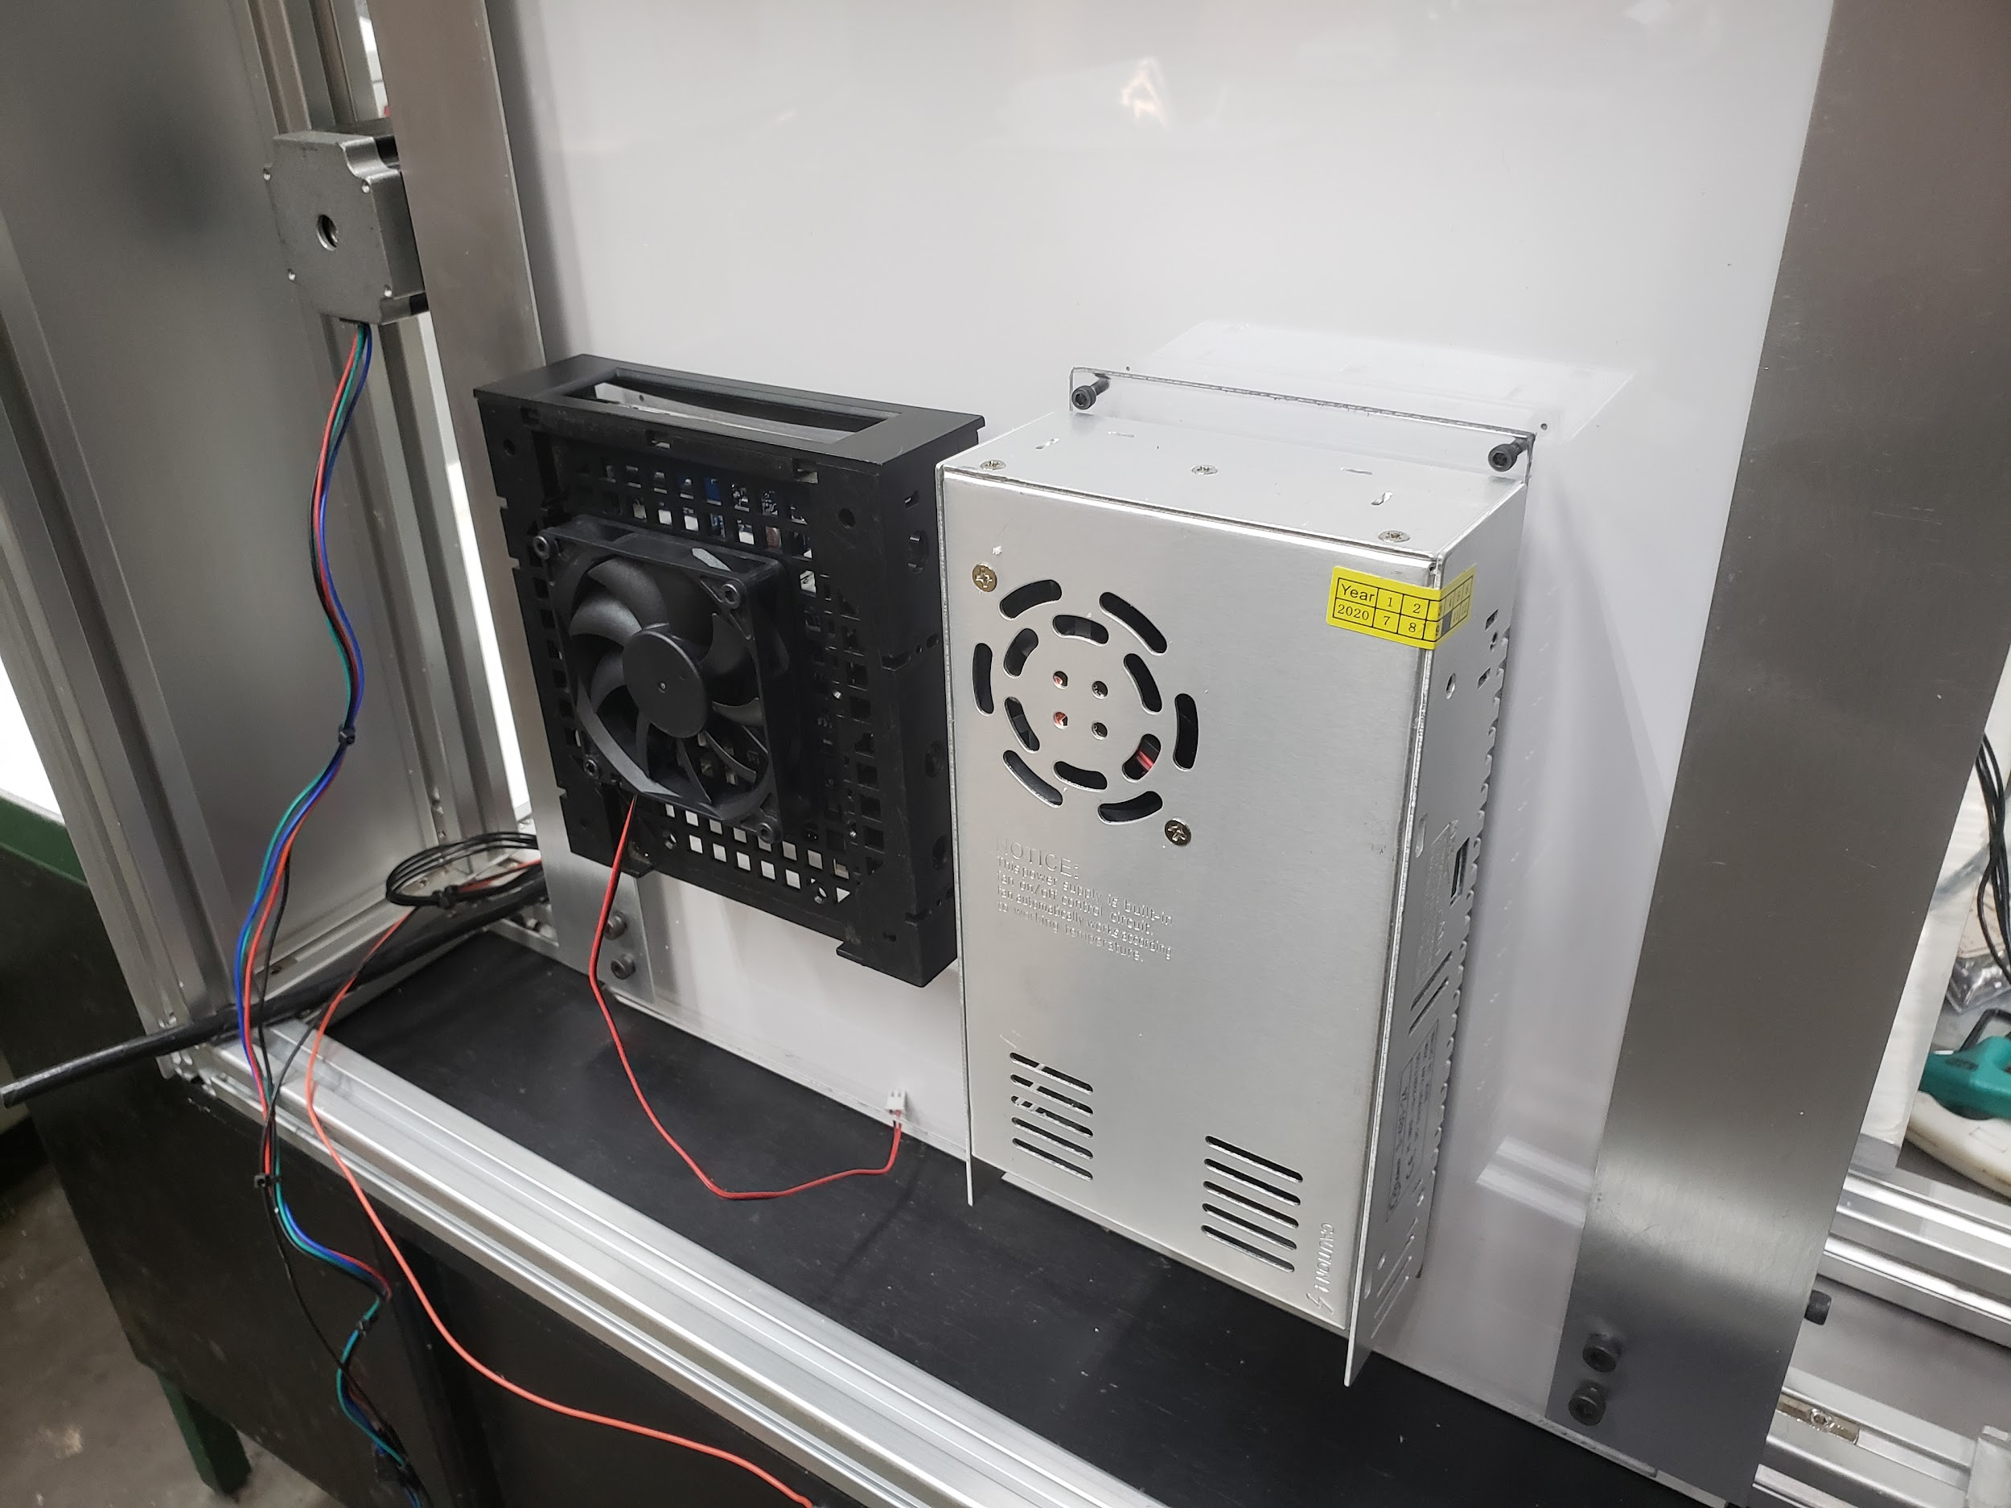

Most 3d printers use either 12V or 24V
- Hotend 12V heater cartridge can draw up to 4A
- A heated bed can draw nearly 12A.
- Cheaper 26-gauge wire are rated at 2 amps

If your wire gauge is not large enough or longer than needed the resistance will be higher This means less watts going through the wire.

Copper wire size uses the American Wire Gauge (AWG). The lower the gauge number, the less resistance the wire has and therefore the higher current it can handle safely.

D Intersect CURRENT IN AMPS with LENGTH IN FEET to identify the wire size.

Stepper Motor Wiring
Rated Current is the maximum current that can pass through both windings at the same time. Set the motor current to no more than about 85% of the rated current. To get maximum torque out of your motors without overheating them, you should choose motors with a current rating no more than 25% higher than the recommended maximum stepper driver current.

- Nema 17 Stepper Motors: 22 AWG wire with 4 conductors
- NEMA 17 motor wires are 26 AWG

Most motor torque data assumed 24 Volts, at 1.1 amp to 1.5 amp. Roughly 26 to 36 Watts, but remember that's "chopped" or pulsed.
Wire size is based on power transmission requirements and length of wire.

10 gauge wire - 30 amps
12 gauge wire - 20 amps
14 gauge wire - 15 amps
16 gauge wire - 10 amps
18 gauge wire - 7 amps
20 gauge wire - 3 amps (or slightly more)
22 gauge wire - 2 amps

Stranded wire is best for lengthening motor wires, get 9 strands or more. Solder properly and heat shrink. 20 AWG or larger.

Use a shielded 4-core high current wire, so that the wiring creates much less capacitive and induced interference or a twisted pair of twisted pairs.
Each individual winding should have a twisted pair, and these two pairs should be twisted (in the opposite sense) together. Twisted pair will reduce induced interference to a minimum, and twist-on-twist is a very flexible way to combine 4 wires. Alas the construction will couple capacitively to nearby signal cables, so it pays to keep separate from them, or ensure all signal cables are shielded. (Signal cables are things like limit switch wiring, encoders, etc).
Using a cordless drill and a bench vice, keep enough tension to prevent kinking, and reverse briefly to lose any torsion before releasing the wires.

Wire Connectors
The molex 4 pin connector is rated at about 14 Amps (.093 inch / 2.36 mm diameter terminals.

Wire Gauge Chart

AWG gauge | Conductor  Diameter Inches | Conductor  Diameter mm | Conductor cross section in mm² | Max Amps for wiring | Max amps for  power transmission
0000 | 0.46 | 11.684 | 107 | 380 | 302
000 | 0.4096 | 10.40384 | 84.9 | 328 | 239
00 | 0.3648 | 9.26592 | 67.4 | 283 | 190
0 | 0.3249 | 8.25246 | 53.5 | 245 | 150
1 | 0.2893 | 7.34822 | 42.4 | 211 | 119
2 | 0.2576 | 6.54304 | 33.6 | 181 | 94
3 | 0.2294 | 5.82676 | 26.7 | 158 | 75
4 | 0.2043 | 5.18922 | 21.1 | 135 | 60
5 | 0.1819 | 4.62026 | 16.8 | 118 | 47
6 | 0.162 | 4.1148 | 13.3 | 101 | 37
7 | 0.1443 | 3.66522 | 10.6 | 89 | 30
8 | 0.1285 | 3.2639 | 8.37 | 73 | 24
9 | 0.1144 | 2.90576 | 6.63 | 64 | 19
10 | 0.1019 | 2.58826 | 5.26 | 55 | 15
11 | 0.0907 | 2.30378 | 4.17 | 47 | 12
12 | 0.0808 | 2.05232 | 3.31 | 41 | 9.3
13 | 0.072 | 1.8288 | 2.63 | 35 | 7.4
14 | 0.0641 | 1.62814 | 2.08 | 32 | 5.9
15 | 0.0571 | 1.45034 | 1.65 | 28 | 4.7
16 | 0.0508 | 1.29032 | 1.31 | 22 | 3.7
17 | 0.0453 | 1.15062 | 1.04 | 19 | 2.9
18 | 0.0403 | 1.02362 | 0.823 | 16 | 2.3
19 | 0.0359 | 0.91186 | 0.653 | 14 | 1.8
20 | 0.032 | 0.8128 | 0.519 | 11 | 1.5
21 | 0.0285 | 0.7239 | 0.412 | 9 | 1.2
22 | 0.0253 | 0.64516 | 0.327 | 7 | 0.92
23 | 0.0226 | 0.57404 | 0.259 | 4.7 | 0.729
24 | 0.0201 | 0.51054 | 0.205 | 3.5 | 0.577
25 | 0.0179 | 0.45466 | 0.162 | 2.7 | 0.457
26 | 0.0159 | 0.40386 | 0.128 | 2.2 | 0.361

Motor Current
- Maximum motor current 1.5A peak => Stepper motor rated current <= 1.9A
- Maximum motor current 2.5A peak => Stepper motor rated current <= 3.0A
- Maximum motor current 1.6A peak with good fan cooling => Stepper motor rated current <= 1.7A.

Use motors with lower rated current (e.g. 1.0 to 1.2A) and 24V power, then the drivers will run cooler.

Duet 3 Current
Duet 3 Mainboard 6HC and Expansion board 3HC has a recommended maximum motor current 6.3A peak/4.45A RMS) => Stepper motor rated current <= 6A
Duet 3 Toolboard has a recommended maximum motor current 1.4A peak) => Stepper motor rated current <= 1.75A

2B 2A 1A 1B

One solution is twisted pairs of wire to have one wire carrying the current while the other brings the current back.

Calculating Wire Size
A higher voltage means a lower current for the same amount of power. This gives you the opportunity to use smaller wires for the same job. Voltage is proportional to the current. A higher voltage means a lower current. Wire size influences the amount of current that can pass through it.

- A thicker wire will have less resistance per length
- Less resistance means loss
- The less loss means less temperature increase
In terms of wire size, 24V has an advantage over 12V, as the wires can be much smaller.
A power supply of 300 watts running at 12V or 24V, will use less wire.

Voltage | Current | Power
12V | 4A | 48W
24V | 2A | 48W

Wire Sizing Chart and Formula
Calculate the Voltage Drop Index (VDI) using the following formula:
- VDI = AMPS x FEET ÷ (% VOLT DROP x VOLTAGE)
- Determine the appropriate wire size from the chart above.

To compensate for voltage-drop, heat and current changes it is recommended to use 6 gauge wire and 4 gauge for over 15 feet.

Related Content

WorkHorse 3D Printer

Duet3D

Electronics

Stepper Motor Holding Torque

Electronics

Duet 3

Duet 3 Wiring Guide

Duet Wifi

RepRap Firmware

Docs

Stepper Motors

How To Calculate Stepper Motor RPM?

Stepper Motor Holding Torque

Unipolar vs Bipolar Stepper Motors

EndStops

0.9 vs 1.8 degrees Stepper Motors

WorkHorse-3D Printer Wiring

Dual X-Axis / Dual Z

